Press release
SINEAX DM5: The next generation of transducers
Universal heavy current technology with maximum precision

(Wohlen AG, November 2017) The SINEAX DM5 series of devices are programmable universal measurement instruments for heavy current networks: classic high precision transducers for top hat rail mounting, they are suitable for almost any type of monitoring function and as well as for retrofitting in energy distribution and industry.
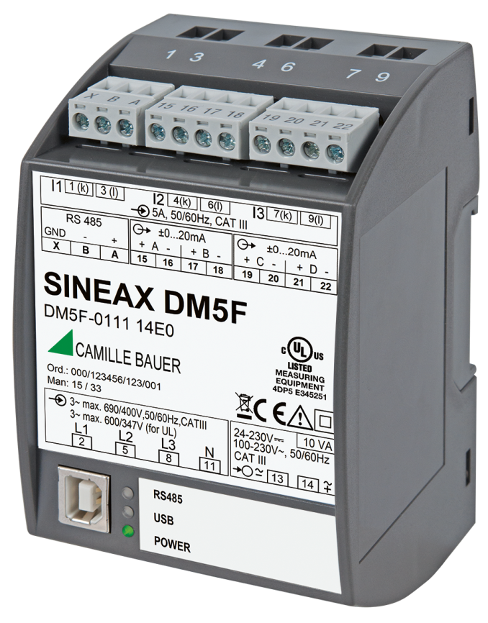

A powerful generation
The DM5S transducer is the latest addition to Camille Bauer Metrawatt's large product portfolio. Just like the SINEAX M1000, the predecessor model, and a world first for this type of device, the main function of the DM5S is highly accurate representation of the basic parameters of an electrical network. It then transmits this representation securely via analogue outputs or a digital interface.
DM5x: Maximum programming simplicity via USB, even without auxiliary power supply

A coherent design generates efficiency
The basic accuracy of the DM5 is 0.15% for current and voltage, 0.2% for power ratings and 0.5S for energy counters. The highlights of the new series are its many selectable options and the fact that measurement values are captured continuously (zero-blind measurement). In addition, the device can be individually configured even without being connected to auxiliary power. The optimised and compact design not only saves space, but also reduces cost. DM5S supports up to 32 counters with up to 16 tariffs, while the DM5F delivers very high processing speeds of up to 15 ms. This makes it easy to implement even the most demanding applications such as turbine control systems.

Getting started the easy way
The free "CB Manager" software is not just used to set up the device parameters, it also provides utility functions to support the user to get started, such as printing product identification labels, checking connections, recording measurement values as well as simulation and trimming the analogue outputs. Users can freely define the Modbus mapping of the optional Modbus interface. This ensures optimised data retrieval by fetching all the relevant data in a single access.

Quality and excellence – independently certified
DM5 series devices are UL-certified and are regularly audited by an independent test lab. This ensures that they are always compliant with the latest standards and that each device works perfectly. The UL certification is combined with end-to-end monitoring of the whole production process. This ensures that only qualified components are used, and only documented production processes are performed. It allows for a constantly high level of product quality, in conformity with all safety and EMC standards.

Further information available at www.camillebauer.com/dm5-en

----------------------------------------------------------------------------------------------------------------------------------------

Number of characters (with spaces): approx. 2‘626
This article and the image are approved for publication.

Press contact: Camille Bauer Metrawatt AG
Sascha Engel
Aargauerstrasse 7
CH-5610 Wohlen
t +41 56 618 21 11
f +41 56 618 21 21
sascha.engel@camillebauer.com
www.camillebauer.com

Camille Bauer Metrawatt AG

Camille Bauer Metrawatt AG is a Swiss medium-sized company for the development and production of industrial measurement equipment. Organised in two busines units, Camille Bauer offers customers application oriented solutions in the high-voltage monitoring and position sensoring. The company is part of the GMC-I with headquarters in Nürnberg, Germany and as such with ist worldwide representatives in a renowned supplier for the measurement of electrical and energetic parameters. This includes a deep understanding of the needs of the electrical energy generation, distribution of energy as well as the industrial consumers. With its Swiss regard for highest quality and its strong capacity for innovation Camille Bauer Metrawatt AG delivers measurable added value to its customers. More Information availabe from www.camillebauer.com

